Lesson 7: Distance on the Coordinate Plane

Mrs. Faour/Lesson Notes

|  |
| --- |
| * Use the absolute value to determine the distance between integers on the coordinate plane in order to find side lengths of polygons. * All of the segments are *all either vertical or horizontal.* * *If the $x$-coordinates were the same for both points, then the segment was vertical.* * *If the $y$-coordinates were the same, then the segment was horizontal.* * How did you calculate the length of the segments given the coordinates of the endpoints?   *\*If the coordinates that were not the same had the same sign, we subtracted the absolute values of the coordinates.*  *\*If the coordinates that were not the same had different signs, we added the absolute values of the coordinates.* |

You are required to submit the following:

* Copy Notes/Math notebook
* Complete the Problem-Set (1-6)
* Exit Ticket

Classwork

Example

Determine the lengths of the given line segments by determining the distance between the two endpoints.

|  |  |  |  |  |  |  |  |  |  |  |  |  |  |  |  |  |  |  |  |  |  |  |  |  |  |  |  |  |  |  |  |  |  |  |  |  |  |  |  |  |  |  |  |  |  |  |  |  |  |  |  |  |  |  |  |  |  |  |  |  |  |
| --- | --- | --- | --- | --- | --- | --- | --- | --- | --- | --- | --- | --- | --- | --- | --- | --- | --- | --- | --- | --- | --- | --- | --- | --- | --- | --- | --- | --- | --- | --- | --- | --- | --- | --- | --- | --- | --- | --- | --- | --- | --- | --- | --- | --- | --- | --- | --- | --- | --- | --- | --- | --- | --- | --- | --- | --- | --- | --- | --- | --- | --- |
| |  |  |  |  |  | | --- | --- | --- | --- | --- | | **Line Segment** | **Point** | **Point** | **Distance** | **Proof** | |  |  |  |  |  | |  |  |  |  |  | |  |  |  |  |  | |  |  |  |  |  | |  |  |  |  |  | |  |  |  |  |  | |  |  |  |  |  | |  |  |  |  |  | |  |  |  |  |  | |  |  |  |  |  | |  |  |  |  |  | |  |

|  |  |  |  |  |
| --- | --- | --- | --- | --- |
| **Line Segment** | **Point** | **Point** | **Distance** | **Proof** |
|  |  |  |  |  |
|  |  |  |  |  |
|  |  |  |  |  |
|  |  |  |  |  |
|  |  |  |  |  |
|  |  |  |  |  |
|  |  |  |  |  |
|  |  |  |  |  |
|  |  |  |  |  |
|  |  |  |  |  |
|  |  |  |  |  |

Exercise

Complete the table using the diagram on the coordinate plane.

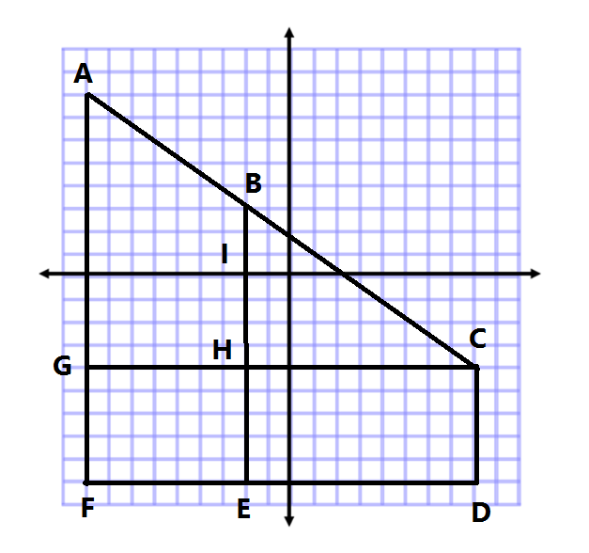

$$y$$

$$x$$

|  |  |  |  |  |
| --- | --- | --- | --- | --- |
| Line Segment | Point | Point | Distance | Proof |
|  |  |  |  |  |
|  |  |  |  |  |
|  |  |  |  |  |
|  |  |  |  |  |
|  |  |  |  |  |
|  |  |  |  |  |
|  |  |  |  |  |
|  |  |  |  |  |
|  |  |  |  |  |
|  |  |  |  |  |

Problem Set

1. Given the pairs of points, determine whether the segment that joins them is horizontal, vertical, or neither.
   1. $X(3, 5)$ and $Y(-2, 5)$
   2. $M(-4, 9)$ and $N(4, -9)$
   3. $E(-7, 1)$ and $F(-7, 4)$
2. Complete the table using absolute value to determine the lengths of the line segments.

|  |  |  |  |  |
| --- | --- | --- | --- | --- |
| **Line Segment** | **Point** | **Point** | **Distance** | **Proof** |
| $$\overline{AB}$$ | $$(-3, 5)$$ | $$(7, 5)$$ |  |  |
| $$\overline{CD}$$ | $$(1, -3)$$ | $$(-6, -3)$$ |  |  |
| $$\overline{EF}$$ | $$(2, -9)$$ | $$(2, -3)$$ |  |  |
| $$\overline{GH}$$ | $$(6, 1)$$ | $$(6, 16)$$ |  |  |
| $$\overline{JK}$$ | $$(-3, 0)$$ | $$(-3, 12)$$ |  |  |

1. Complete the table using the diagram and absolute value to determine the lengths of the line segments.

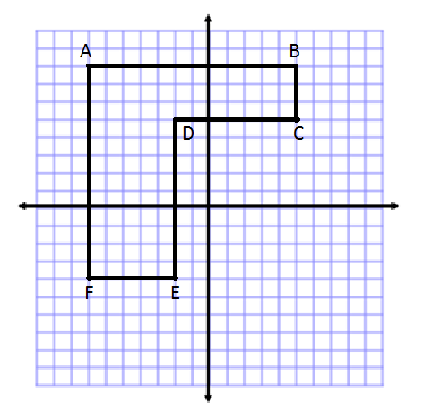

|  |  |  |  |  |
| --- | --- | --- | --- | --- |
| **Line Segment** | **Point** | **Point** | **Distance** | **Proof** |
|  |  |  |  |  |
|  |  |  |  |  |
|  |  |  |  |  |
|  |  |  |  |  |
|  |  |  |  |  |
|  |  |  |  |  |

|  |  |  |  |  |
| --- | --- | --- | --- | --- |
| **Line Segment** | **Point** | **Point** | **Distance** | **Proof** |
| $$\overline{AB}$$ |  |  |  |  |
| $$\overline{CG}$$ |  |  |  |  |
| $$\overline{CF}$$ |  |  |  |  |
| $$\overline{GF}$$ |  |  |  |  |
| $$\overline{DH}$$ |  |  |  |  |
| $$\overline{DE}$$ |  |  |  |  |
| $$\overline{HJ}$$ |  |  |  |  |
| $$\overline{KL}$$ |  |  |  |  |

1. Complete the table using the diagram and absolute value to determine the lengths of the line segments.

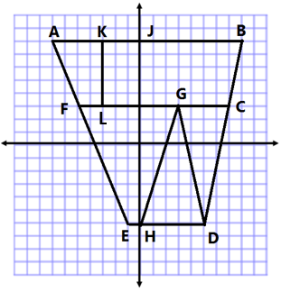

1. Name two points in different quadrants that form a vertical line segment that is $8$ units in length.
2. Name two points in the same quadrant that form a horizontal line segment that is $5$ units in length.